**TEST REPORT**

**TEST_CASE 5.1: sunny testcase**

**LOGIN**

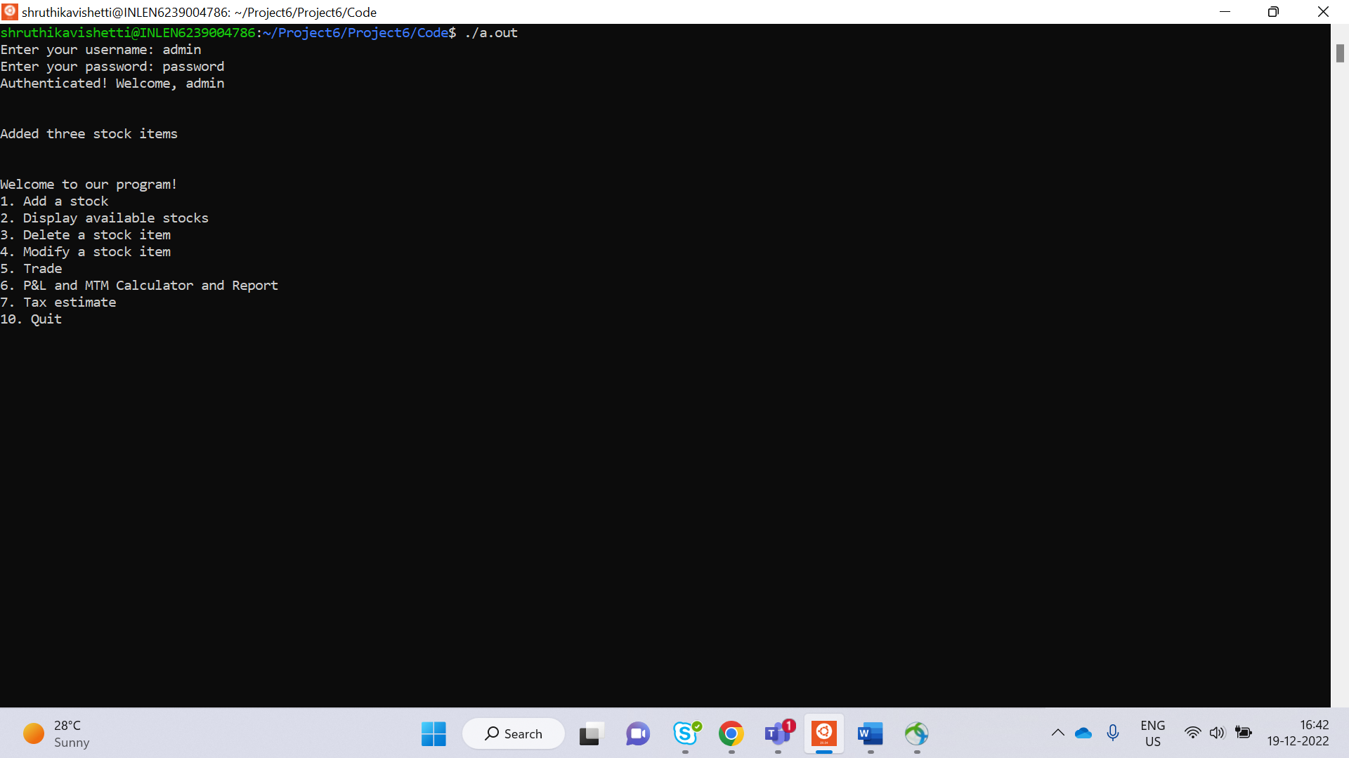

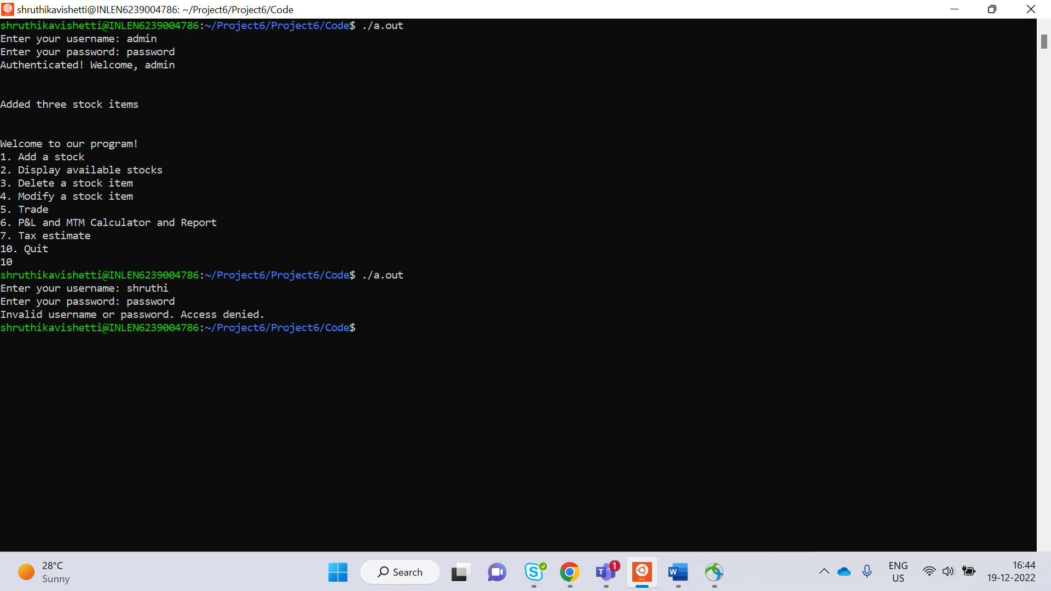

**TEST_CASE 5.2: sunny testcase**

**Menu**

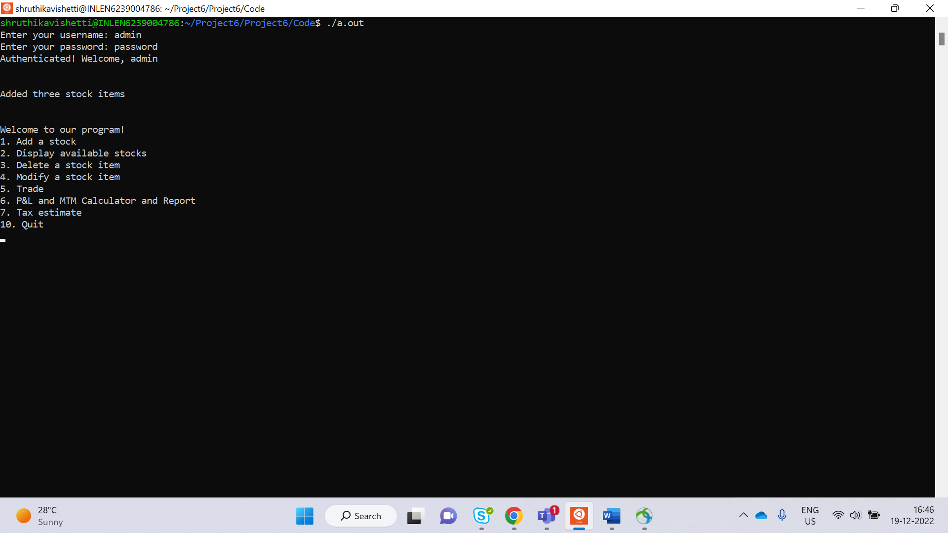

**TEST_CASE 5.3: sunny testcase**

**ADD_STOCK**

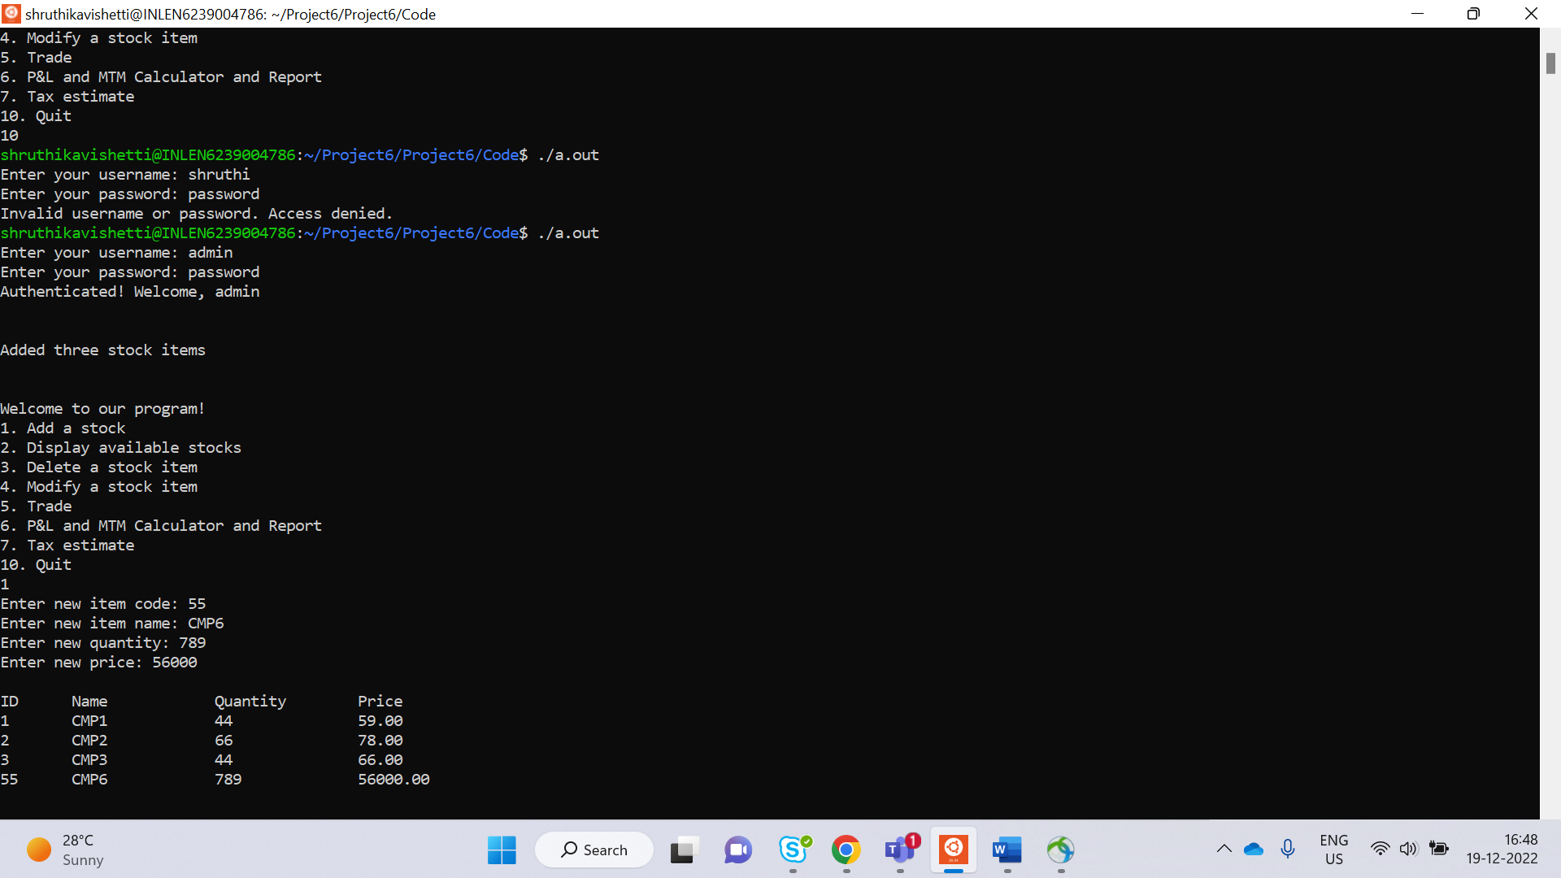

**TEST_CASE 5.4: sunny testcase**

**DISPLAY STOCK**

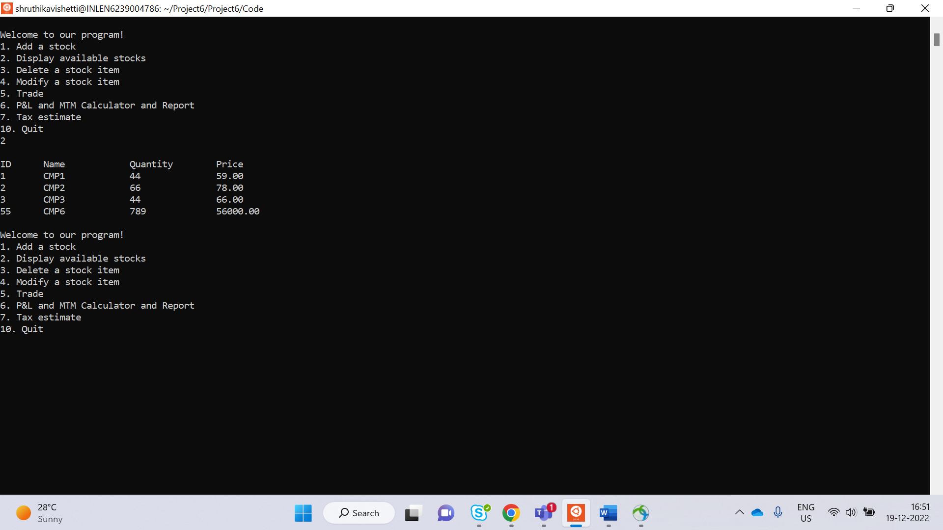

**TEST_CASE 5.5: sunny testcase**

**DELETE STOCK**

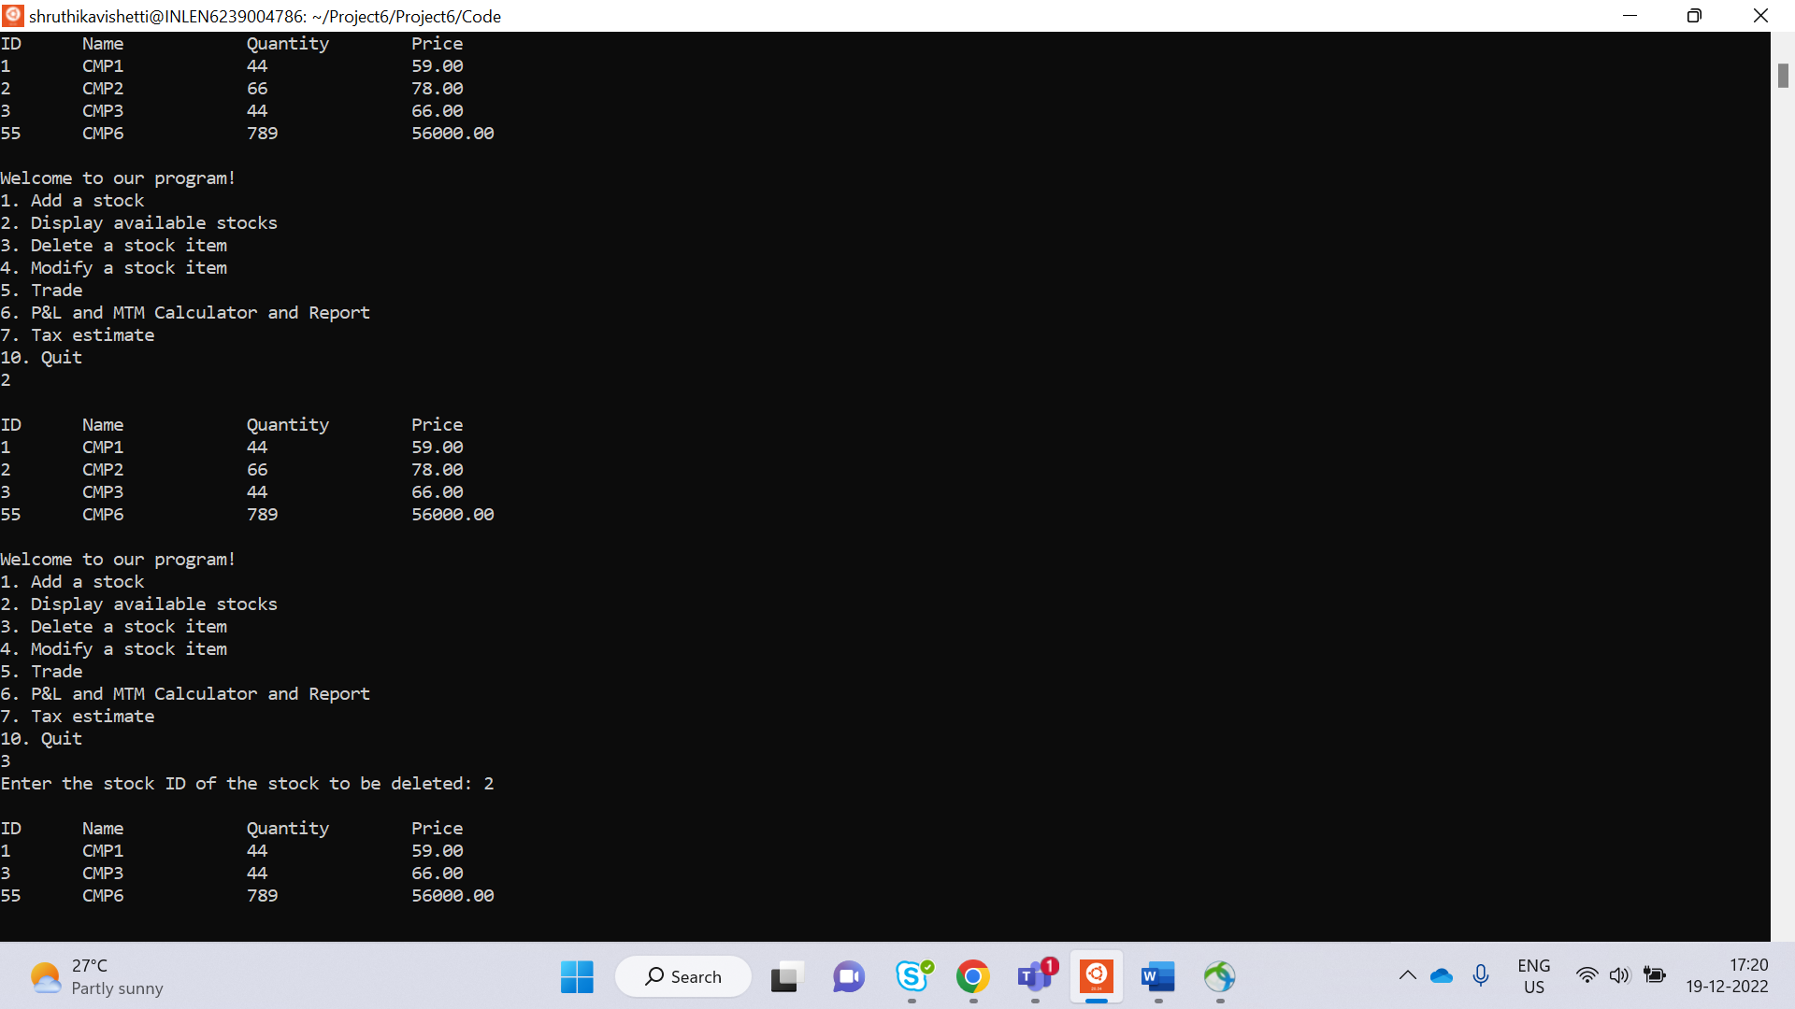

**TEST_CASE 5.6: sunny testcase**

**MODIFY STOCK**

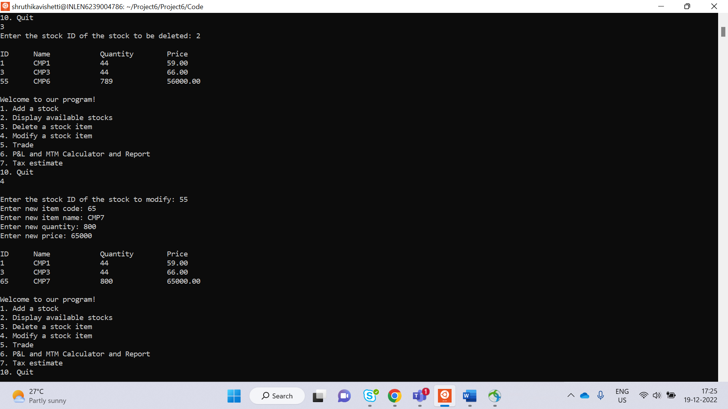

**TEST_CASE**

**TRADE 5.7: sunny testcase**

**BUYING**

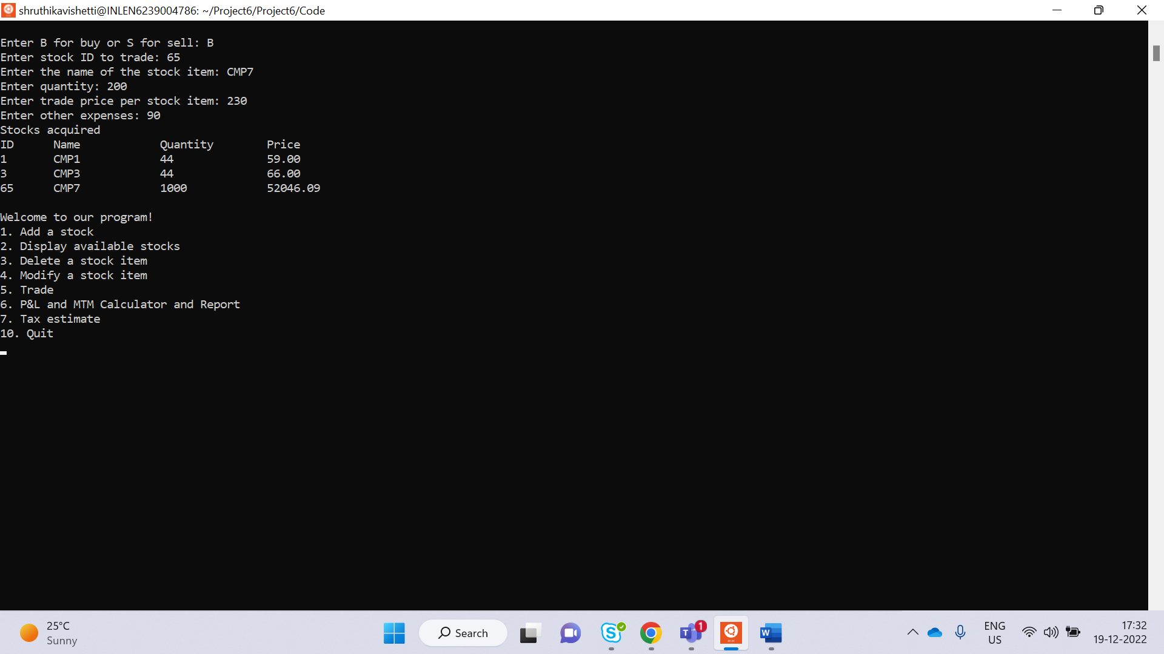

**SELLING**

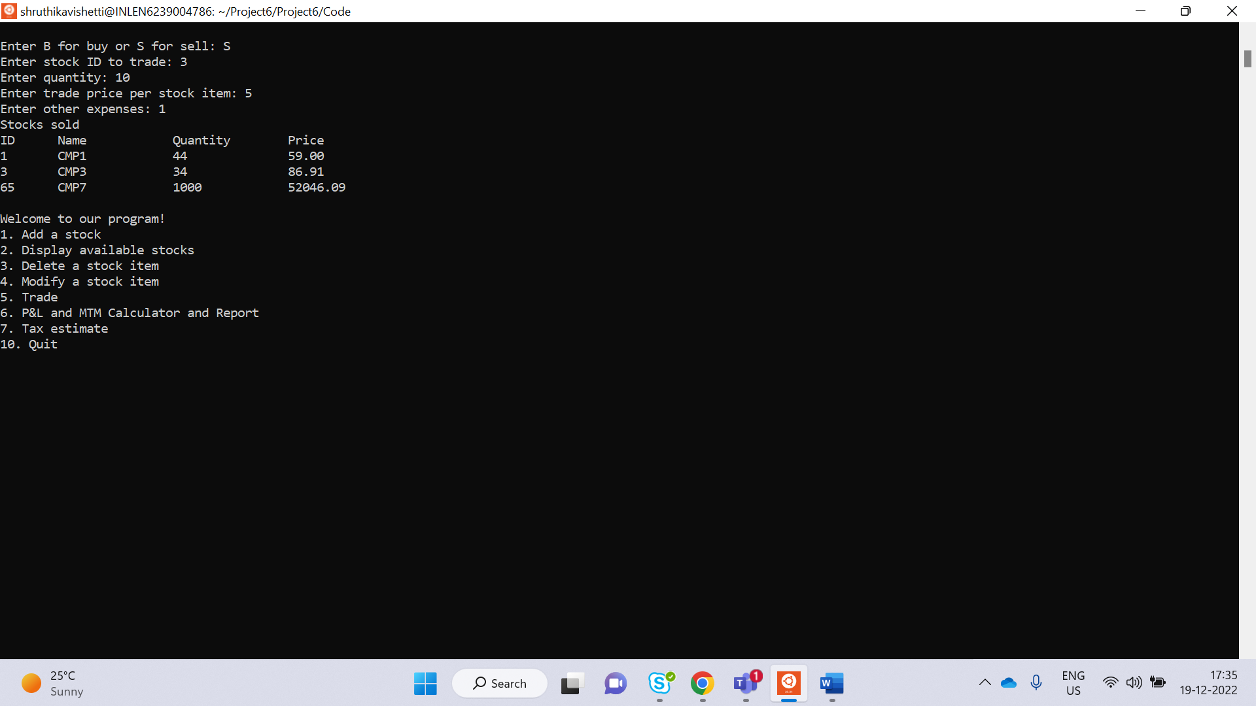

**TEST_CASE 5.8: rainy testcase**

**CALCULATOR**

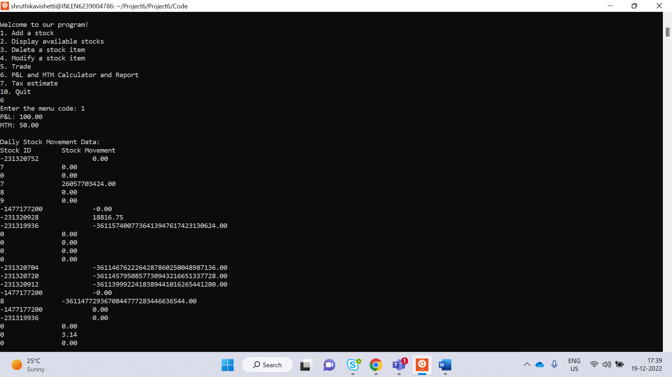

**TEST_CASE 5.9: rainy testcase**

**TAX ESTIMATE**

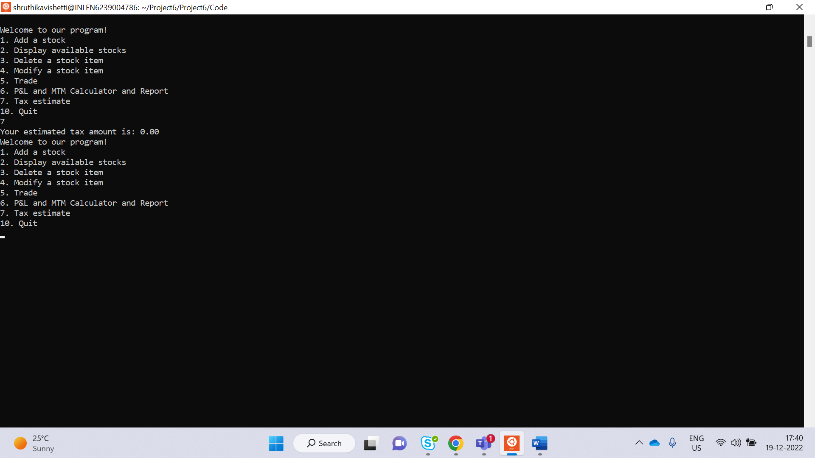

**TEST_CASE 5.10: sunny testcase**

**QUIT**

